**Project Design Phase-II**

**Data Flow Diagram & User Stories**

|  |  |
| --- | --- |
| Date | 22 May 2025 |
| Team ID | LTVIP2025TMID53104 |
| Project Name | LearnHub |
| Maximum Marks | 4 Marks |

**Data Flow Diagrams:**

A Data Flow Diagram (DFD) is a traditional visual representation of the information flows within a system. A neat and clear DFD can depict the right amount of the system requirement graphically. It shows how data enters and leaves the system, what changes the information, and where data is stored.



**Example:**

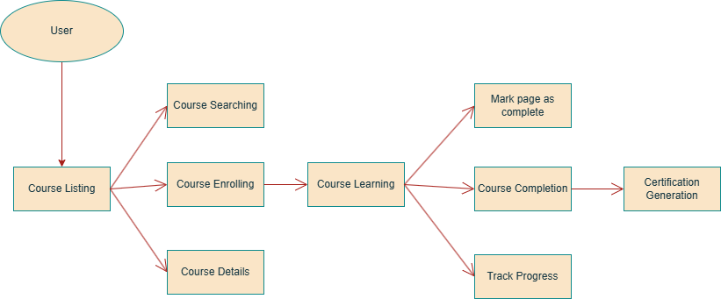

**User Stories**

Use the below template to list all the user stories for the product.

| **User Type** | **Functional Requirement (Epic)** | **User Story Number** | **User Story / Task** | **Acceptance criteria** | **Priority** | **Release** |
| --- | --- | --- | --- | --- | --- | --- |
| Educator |  | USN-1 | As an educator, I can register for the application by entering my email, password, and confirming my password. | I can create an account easily | High | Sprint-1 |
|  |  | USN-2 | As an educator, I can create courses | I can create high quality courses | High | Sprint-1 |
|  |  | USN-3 | As an educator, I can upload videos into my course. Add chapters and pages to courses. | I can add chapters in course, and pages in chapters | High | Sprint-2 |
|  |  |  |  |  |  |  |
| Learner |  | USN-1 | As a learner, I can find latest technology courses | I can easily find latest courses | High | Sprint 1 |
|  |  | USN-2 | As a learner, I should be able to learn from the comfort of my home | I can easily learn any course sitting in my home | High | Sprint 1 |
|  |  | USN-3 | As a learner, I should be able to learn courses in any regional language | I can learn a course in any language I want | Low | Sprint 2 |
|  |  |  |  |  |  |  |
|  |  |  |  |  |  |  |
|  |  |  |  |  |  |  |